University Of Engineering and Technology, Lahore
Computer Engineering Department

Course Name: PF | Course Code: CMPE-112L
Assignment Type: Lab | Dated: 01 June 2026
Semester: 1st | Session: Spring 2026
Lab/Project/Assignment #: 14 | CLOs to be covered: CLO2
Lab Title: OS Library, if __name__ == "__main__", is vs == | Teacher Name: Hafiz Muhammad Mubashar
Lab Evaluation:

CLO1 | Apply appropriate programming techniques to create executable programs to solve well defined problems
 | Level1 | Level2 | Level3 | Level4 | Level5 | Level6
(5)
Total |  |  |  |  |  | /5
Rubrics for Current Lab Evaluation
Scale | Marks | Level | Rubric
Excellent | 5 | L1 | Submitted all lab tasks, BONUS task, have good understanding.
Very Good | 4 | L2 | Submitted the lab tasks but have good understanding
Good | 3 | L3 | Submitted the lab tasks but have weak understanding.
Basic | 2 | L4 | Submitted the lab tasks but have no understanding.
Barely Acceptable | 1 | L5 | Submitted only one lab task.
Not Acceptable | 0 | L6 | Did not attempt
LAB No 14
Lab Goals/Objectives:
• To learn basic functions of the OS library.
• To understand the purpose of if __name__ == "__main__".
• To improve knowledge of Python modules

Equipment Required:
- Computer/Laptop
- Python
- Visual Studio Code / PyCharm / IDLE

Theory:
The os module allows Python programs to interact with the operating system by providing functions for tasks such as creating folders, handling files, and retrieving system-related information. The if __name__ == "__main__" statement makes sure that a Python script is executed only when it is run directly, and not when it is imported into another program. The == operator is used to compare the values of two objects, while the is operator checks whether both variables point to the same object in memory. Learning these concepts helps programmers write cleaner, more organized, and efficient Python code.

Lab Work:

Task 1:
Write a Python program to define and call a `welcome()` function.
Result:
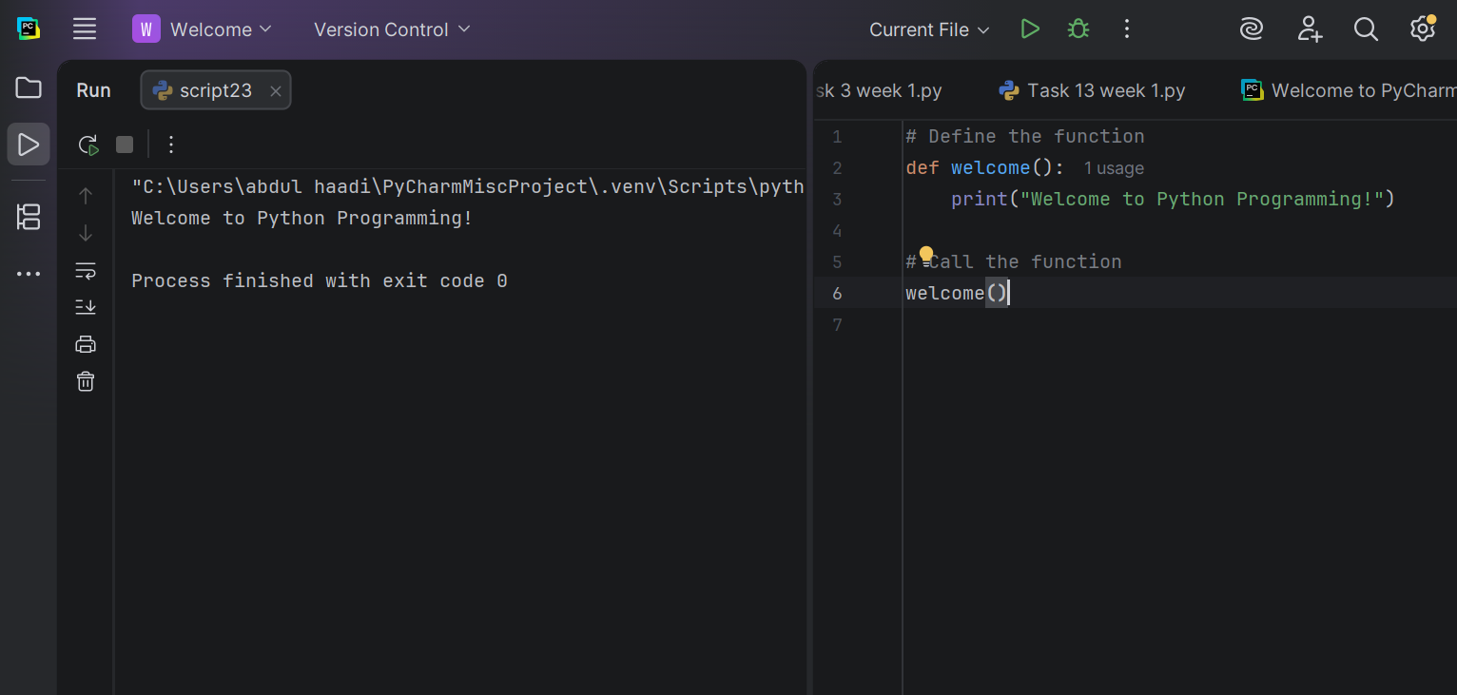

Task 2:
Write a Python program using the `os` module to create a folder named `meta` and then create 100 folders named `meta1` to `meta100`.
Result:

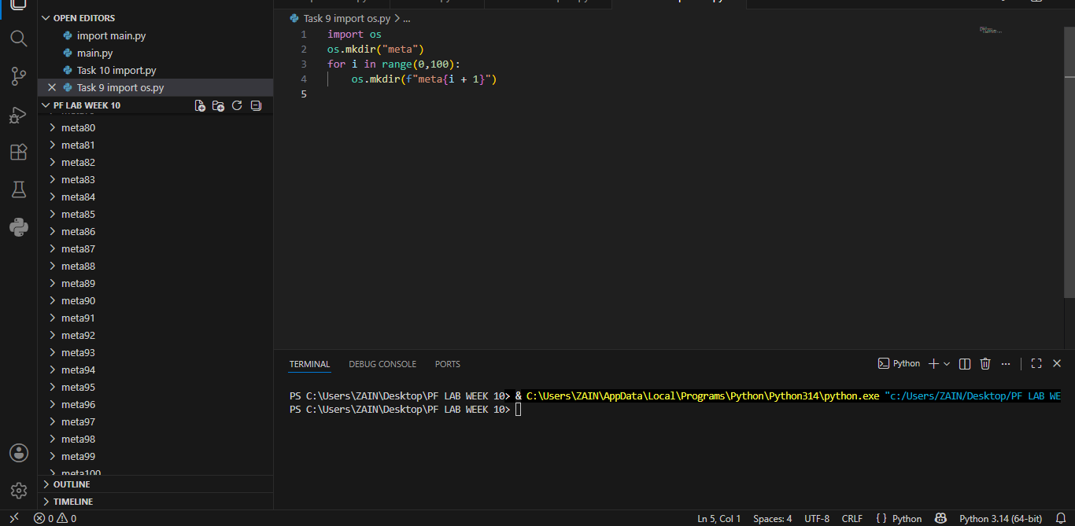

Task 3:
Write a Python program using the `os` module to create
a folder named `NewFolder` and print `Folder created`.
Result:
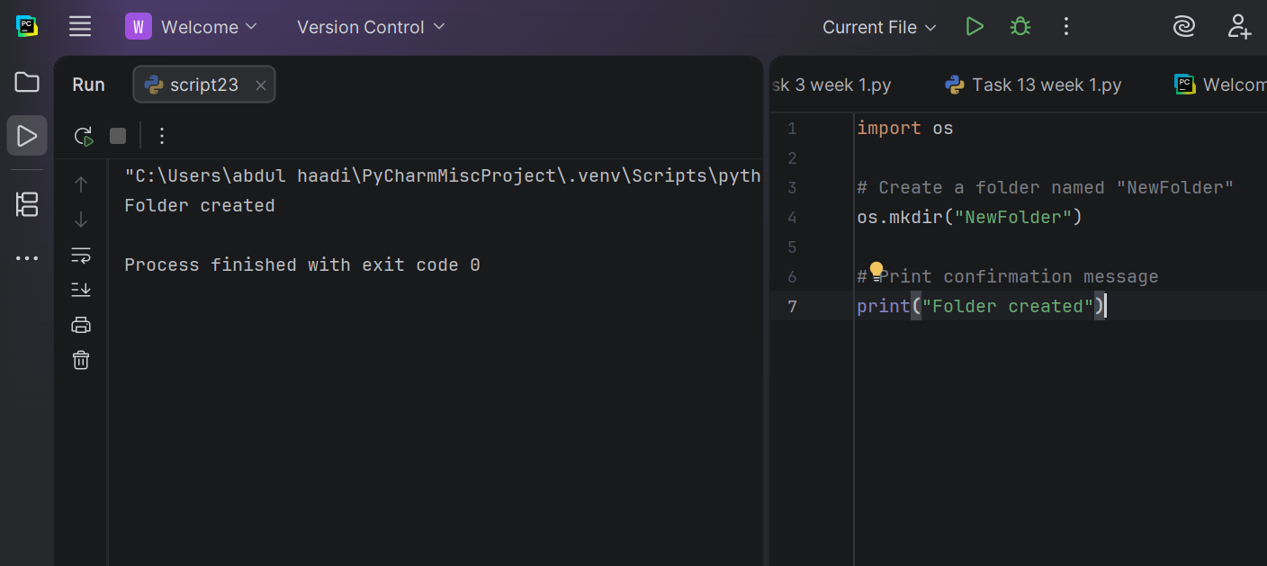
Task 4:
Write a Python program using the `os` module to list and
print all files and folders in the current directory.
Result:
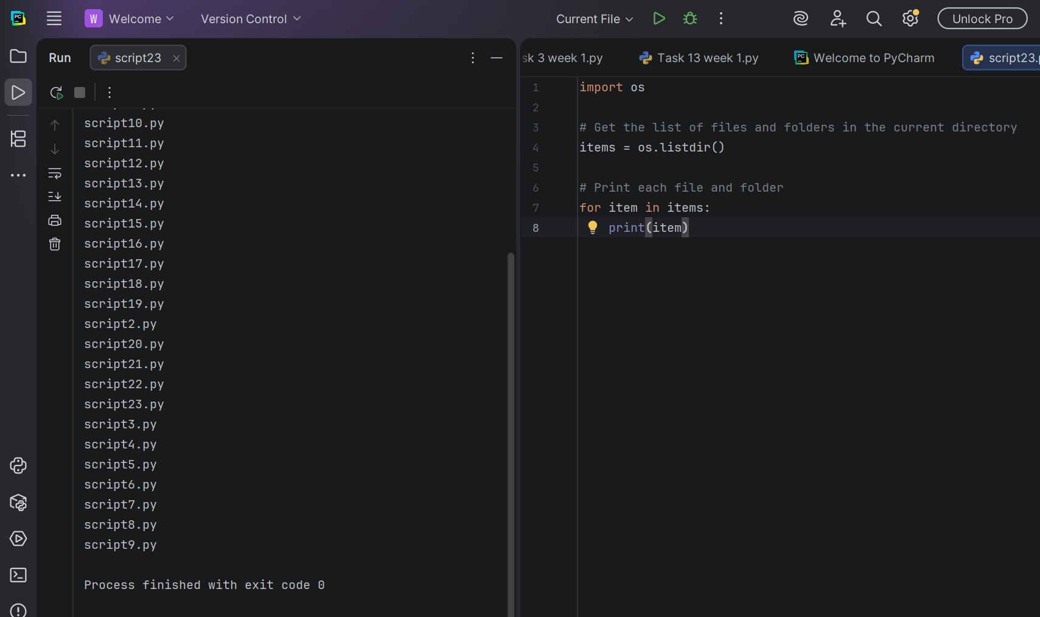

Task 5:

Write a Python program using the `os` module to
rename a file from `old.txt` to `new.txt` and print `File renamed`.
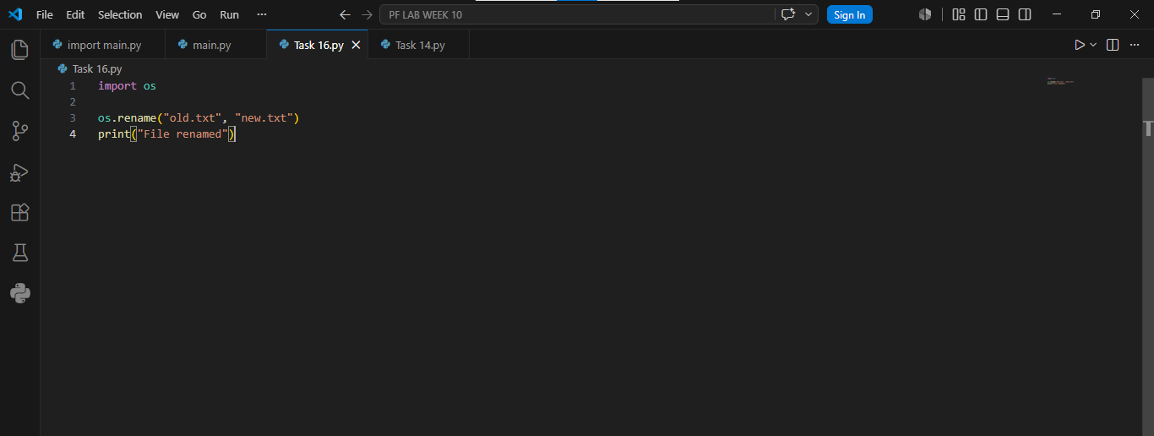
Result
Task 6:
Write a Python program using the `os` module to check if data.txt exists,
print whether the file exists or not
Result:

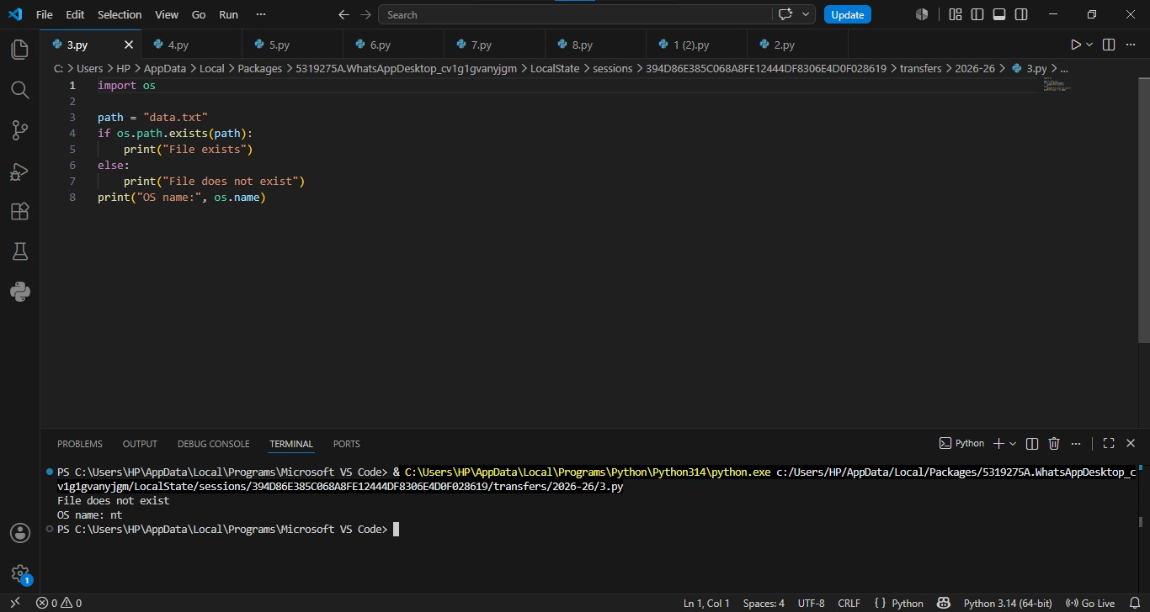

Task 7:
Write a Python program with a `greet()` function that prints `Hello`, and use `if *name* == "*main*":` to print `This runs only when file is executed directly` and call `greet()`.
Result:
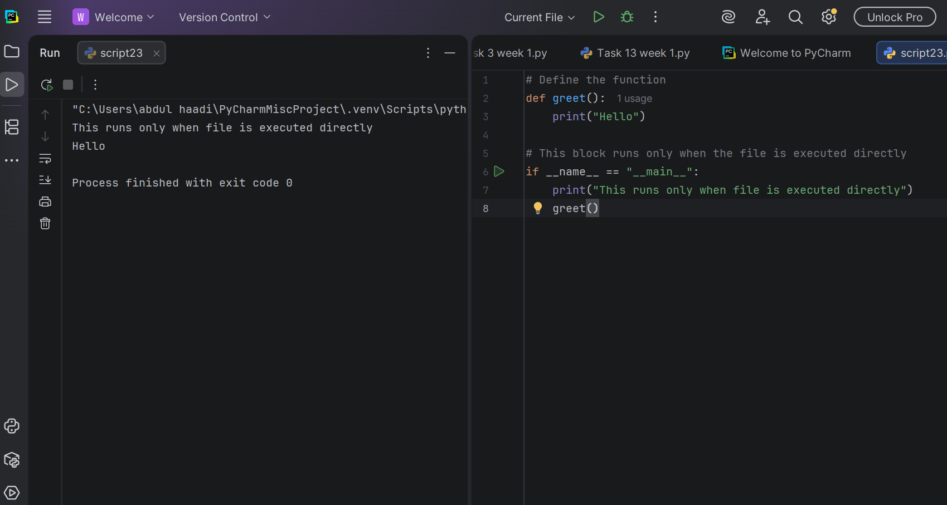
Task 8:
Write a Python program with an `add(a, b)` function that returns the sum of two numbers, and use `if *name* == "*main*":` to add and print the result.
Result:
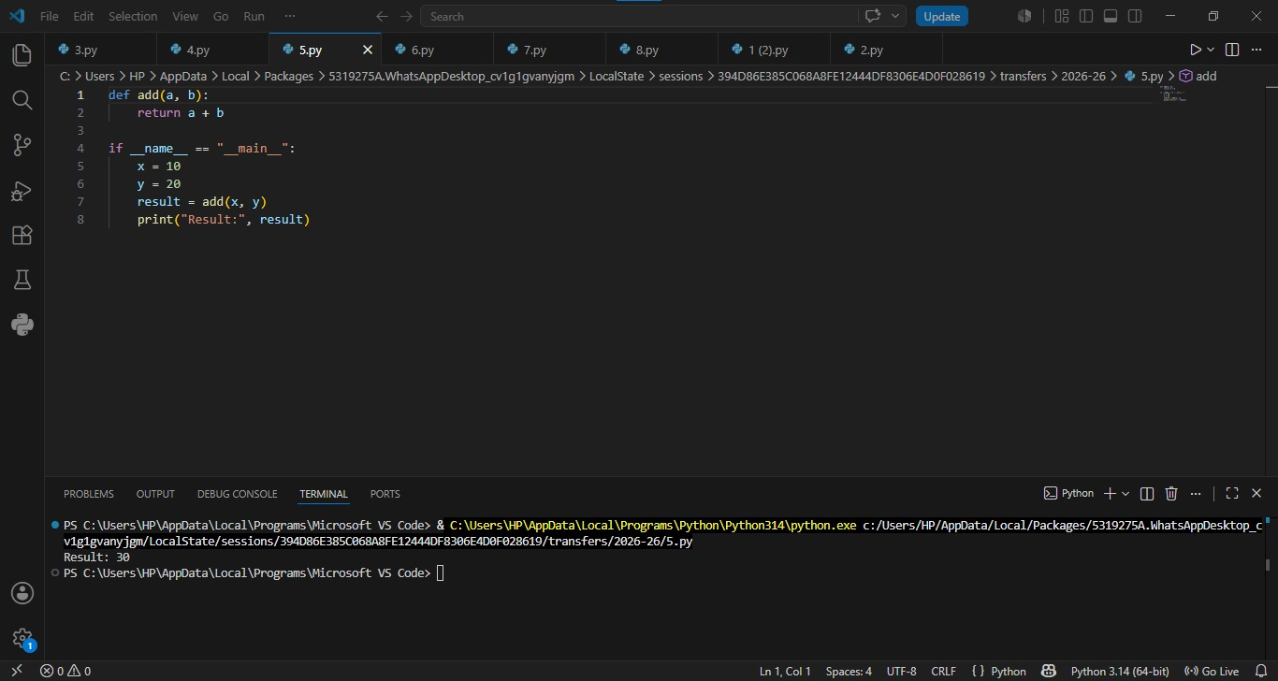

Task 9:
Write a Python program with an `square(n) and cube(n) functions that return the square and cube of a number and use if name == “main”: to set num and print square and cube.
Result:
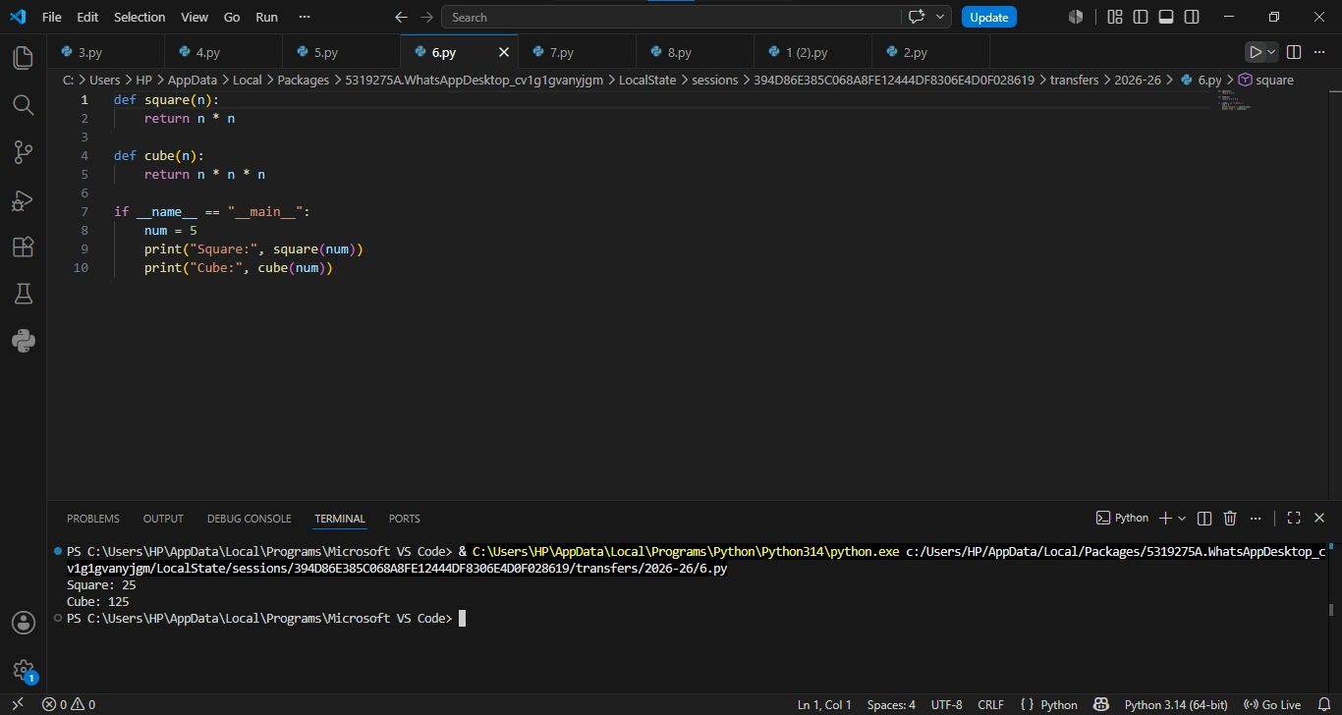

Task 10:
Write a Python program to demonstrate the difference
between == and is by comparing two int and two lists.
Result:

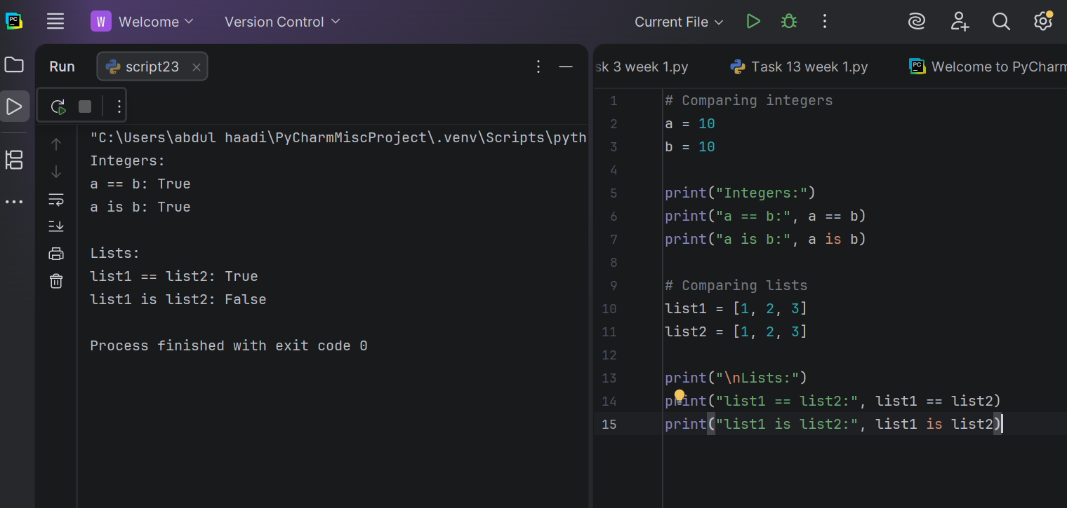

Task 11
Write a Python program to demonstrate `==` vs `is` using `val1 = None` and `val2 = None`, and also check `name with `name
Result:

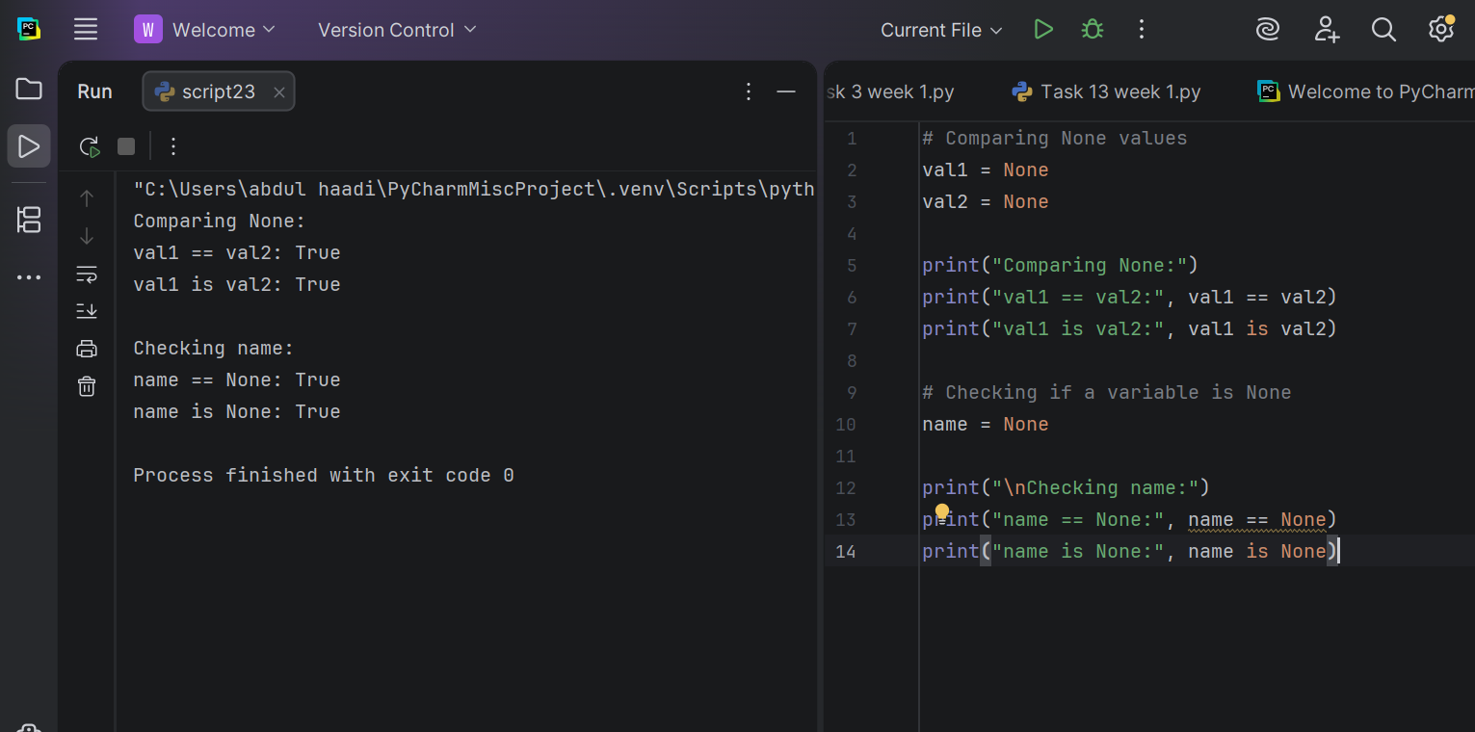 Conclusion
This lab improved our knowledge of several key Python concepts. We learned how to use the os module to work with files and directories, understood the role of the if __name__ == "__main__" statement in controlling when a program executes, and explored the difference between the is operator, which checks object identity, and the == operator, which compares values. These concepts are important for writing organized, efficient, and reliable Python programs.
.

